# Food Ordering Chatbot Project – AVA

## Overview of the Project

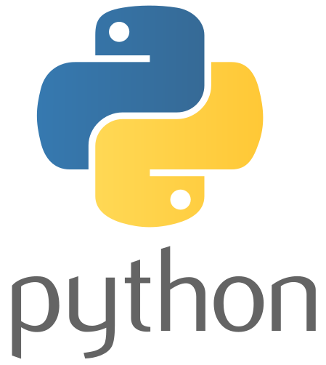The project involves the development of a chatbot named Ava, designed to assist users in placing, tracking, and modifying food orders. The chatbot is embedded within a restaurant's website, called “Pandeji’s eatery” (taken from [codebasics](https://codebasics.io/)) allowing users to interact with it directly. Key functionalities include checking the menu, placing new orders, adding items to existing orders, removing items, confirming orders, and tracking the status of ongoing orders.

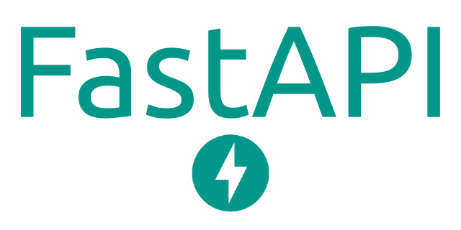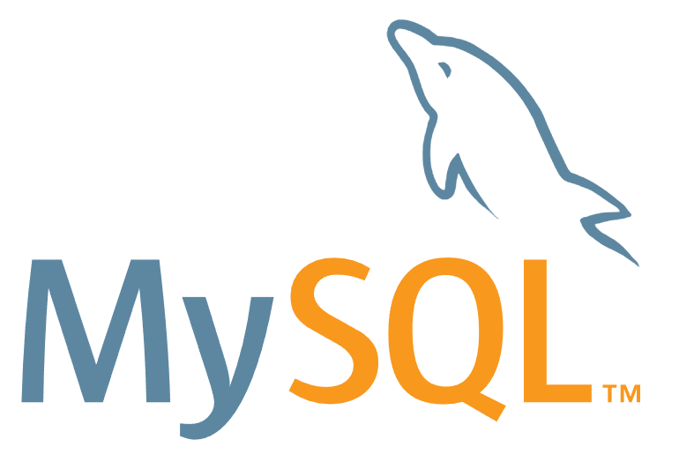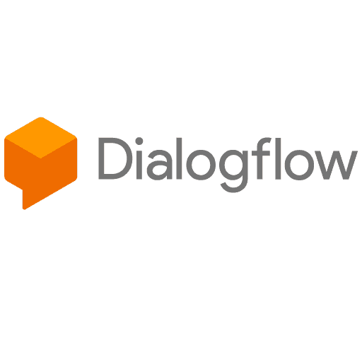

## Techniques, Methods, and Models Used

1. Natural Language Processing (NLP): Utilized Dialogflow for intent recognition, allowing the chatbot to understand user queries and respond appropriately.  
2. Backend Development: FastAPI was employed to create a robust RESTful API that handles requests from the chatbot, interacts with the MySQL database, and manages order processing.  
3. Database Management: MySQL was used to store menu items, order details, and user data. The database schema was designed to facilitate efficient data retrieval and manipulation.  
4. Web Development: Simple HTML and CSS were used to create a user-friendly web interface for the restaurant, incorporating the chatbot for enhanced interactivity.

## Making of the Bot

1. Dialogflow Configuration: Created various intents (e.g., new.order, add.order, remove.order, confirm.order, check.menu, track.order) in Dialogflow to handle different user requests.  
2. Entity Definition: Defined entities for food items, allowing the chatbot to recognize and validate user input for order placement and modification.  
3. Webhook Integration: Set up a webhook using FastAPI to handle requests from Dialogflow, process user input, and return appropriate responses.  
4. Database Interaction: Implemented functions in the FastAPI backend to interact with the MySQL database for CRUD operations related to orders and menu items.

## Key Learnings

Gained hands-on experience in developing chatbots using Dialogflow and integrating them with backend services using FastAPI.  
Learned how to manage data in a MySQL database and implement database operations in a Python environment.  
Developed skills in creating a web interface using HTML and CSS, enhancing user experience through interactive design.  
Improved problem-solving abilities by troubleshooting integration issues between the chatbot, backend, and database.

## Future Developments

1. User Authentication: Implement user authentication and account management features to allow users to save their order history and preferences.  
2. Payment Integration: Add payment processing capabilities to enable users to complete their orders directly through the chatbot interface.  
3. Advanced NLP Features: Enhance the chatbot’s natural language understanding by incorporating machine learning models for better intent recognition and context handling.  
4. Feedback Mechanism: Introduce a feedback system for users to rate their ordering experience, helping to improve service quality.